NAME: TEJAS NALAWADE PRACTICAL NO: 10 ROLL NO: TCOD01
AIM: MongoDB – Aggregation and Indexing: Design and Develop MongoDB Queries using aggregation and indexing with suitable example using MongoDB.

Perform aggregation and Indexing using mongodb on below database
1. Create a database department
2. Create a collection as teacher with fields as name, department, experience and salary
3. Display the department wise average salary.
4. Display the no. Of employees working in each department.
5. Display the department wise minimum salary.
6. Apply index and drop index

1 & 2)
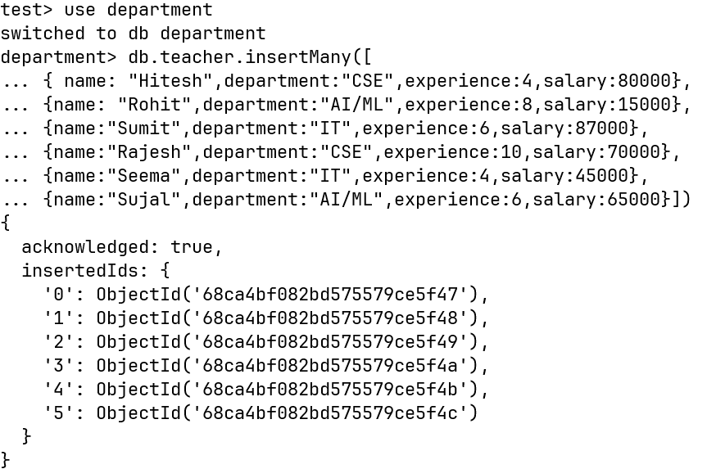

3)

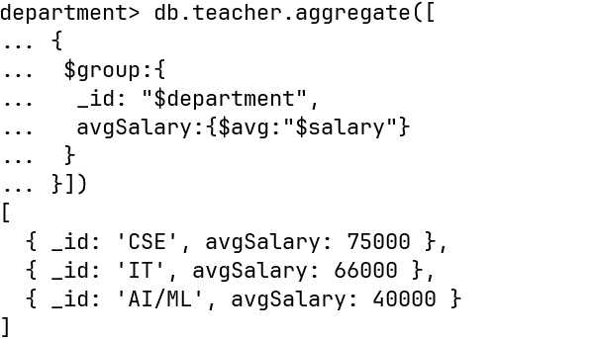

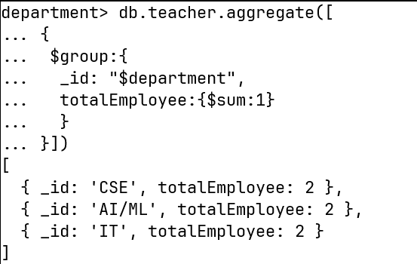
4)

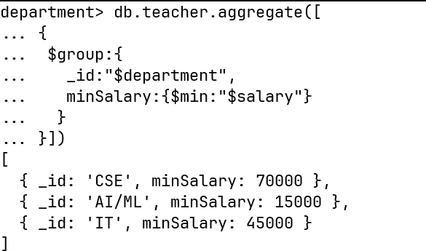
5)

6)

